

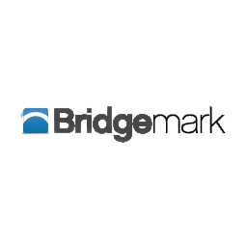

Advisory Services

RAIL-D

Short-Term Marketing Plan

BUS 361 D100 Project Management

Instructor: Dr. Connie Liu

Beedie School of Business

Simon Fraser University

Above the Curve Consulting - Group 4

Jaiden Angeles, James Lee, Emily Chan, Yuling Dai, Daisy Huynh, Tianci Qiao



**Table of Contents**

**1 Planning Basis** **2**

1.1 Scope 2

1.2 Project Goals 3

1.3 Key Tasks and Deliverables 3

Table 3. Key tasks and deliverables 4

1.4 Key Milestones 4

For Bridgemark to understand who the most crucial stakeholders were in creating this project and what their involvement was, a Stakeholder Register was made. 5

1.5 Stakeholder Register 5

**2 Project Plan** **6**

2.1 Timeline 6

2.2 Work Breakdown Structure 6

2.3 Work Breakdown Dictionary 7

2.4 Schedule 8

The schedule indicates what order we will complete each task. For brevity, we cut down the tasks to only include “key tasks” in this section, which are those we determined to have the most impact. The schedule is calculated in two parts: 8

Network Diagram (Critical Path, Slack, Total Duration) 9

2.5 Gantt Chart 10

2.6 Communication Strategies 11

2.7 RACI Matrix 11

**3 Budget, Risks and Change Management** **13**

3.1 Risk Register/Contingency Plan 13

3.2 Evaluation Strategies 13

3.3 Project Budget 14

3.4 Conclusion 15

**4 Appendices** **17**

# 

**Executive Summary**

Above the Curve Consulting is tasked with creating a short-term marketing plan for Bridgemark Advisory Services’ upcoming Remote Artificial Intelligence Logo Device (RAIL-D) project. Since this project is capital-intensive and its output (data) is non-rivalrous, increasing the number of customers will disproportionately increase gross margin (provided marginal costs can be minimized).

Our decision criteria will be primarily focused on feasibility, profitability (in current market conditions), and practicality of implementation. The aforementioned criteria will be used to identify potential future Bridgemark clients/partners and their requirements, culminating in an archetypical B2B digital pamphlet that can be utilized as a basis for Bridgemark’s future marketing.

Due to the short-term nature of this project, Above the Curve Consulting will be exclusively focusing on firms that are:

1. Potential Bridgemark clients/partners within 12 months

2. Require minimal additional labour/capital allocation from Bridgemark

3. Operating within Canada

The primary audience for this document is our sponsor, Mr. Simran Gill from Bridgemark Advisory Services. As the senior partner in this collaboration, he will ultimately be deciding on the future of this project.

The secondary audience for this document is our professor, Dr. Connie Liu, who will be evaluating Above the Curve Consulting’s performance in relation to the course learning outcomes.

Above the Curve’s project plan covers, in detail, the overall project scheduling, milestones, methodologies, and deliverables, plus estimates for costs and identifiable risks. Above the Curve’s project plan is formed under the principle of “as detailed as necessary, as simple as possible.” Most sections consist of an abridged, adapted version of our internal documents (full versions can be found in the appendix) along with a brief explanation.

# 

# Planning Basis

## Scope

The purpose of this project is to create a short-term marketing plan for Bridgemark Advisory Services’ “Remote Artificial Intelligence Logo Device” (RAIL-D), which is an object that tracks railcar logos to create estimates and trend projections of competitor’s sales. We will conduct market research in Canada for two to three profitable industries of expansion for the RAIL-D with minimal adjustments to the object, which will assist Equity Research analysts collect data in further fields.

## Project Goals

Table 1 displays a list of goals we aim to achieve throughout the entire project. Identifying the project goals will help stakeholders understand the key activities needed to successfully execute the proposed project. The project goals also exist to prevent confusion due to the absence of clear and understandable objectives.

| Project Goal | Uses | Priority |
| --- | --- | --- |
| Identify 2-3 profitable industries | Narrow down specific industries for in-depth research | High |
| Identify 1-3 companies per industry | Recommend specific companies for Bridgemark Management | High |
| Produce feasibility and market analysis | Determine the viability of the recommended industries | High |
| Create pamphlet to summarize key recommendations | Brief stakeholders on RAIL-D capabilities and what to market to selected industries | Medium |
| Review and support client’s needs | Ensure objectives are met | High |
| Communicate with prototype team | Inquire specific information about AI data collection tool and ensure shared vision | Low |

**Table 1.** Project Goals

After identifying the goals for this project, we identified the key deliverables and underlying tasks needed to reach our project goals in the following section.

## Key Tasks and Deliverables

A deliverable are the final products or results that will be produced after we have completed all underlying tasks and processes. We have three deliverables, seen in the table below (Table 3), which are correlated with key tasks to complete each deliverable. The deliverables include Market Research, the Marketing Plan, and the Marketing Proposal:

* **Market Research:** The purpose of the *market research* is to provide information on the potential markets that would be interested in using an AI data collection tool.
* **Marketing Plan:** After identifying the potential markets, we will create a *marketing plan* consisting of a feasibility and market analysis of the targeted industries. We will recommend two or three profitable industries for Bridge mark Management as well.
* **Marketing Proposal:** Finally, we will communicate with the prototyping team for the finalized design of the AI tool and create a *marketing proposal* that summarizes the key information.

| Deliverables | Key Tasks |
| --- | --- |
| Market Research  (on 2-3 profitable industries) | Create survey questions & send to companies |
| Conduct online research |
| Conduct SWOT & Pricing Analysis |
| Identify 2-3 profitable companies per industry |
| Marketing Plan  (Short-term for the RAIL-D) | Identify 4Ps Market Strategy (Product, Price, Place, Promotion​) |
| Create feasibility analysis report (economic, organizational, technical) |
| Marketing Proposal  (B2B sales pamphlets) | Create and design the pamphlet |
| Write pamphlet content |

## Table 3. Key tasks and deliverables

To ensure that the project meets its goals, key milestones were created from the key tasks and deliverables to track the overall progress of the project.

## Key Milestones

The milestones are a list of major deadlines that need to be completed by a specified predetermined date to help ensure the RAIL-D project stays within the predetermined time constraints. Table 2 illustrates the milestones, status, and delivery date.

| Milestone | Status | Delivery Date |
| --- | --- | --- |
| Scope statement approved | The scope statement was approved by the Project Sponsor | September 30, 2022 |
| Obtained survey results | Survey has been sent to various clients | October 25, 2022 |
| 2-3 profitable industries identified | In progress | October 30, 2022 |
| 2-3 companies identified per industry | In progress | October 31, 2022 |
| Feasibility analysis | Not started | November 5, 2022 |
| Market analysis | Not started | November 11, 2022 |
| Pamphlet | Not started | December 2, 2022 |

**Table 2.** Milestones

## 

## For Bridgemark to understand who the most crucial stakeholders were in creating this project and what their involvement was, a Stakeholder Register was made.

## Stakeholder Register

Since stakeholders can impact the project’s development, Bridgemark must know the active stakeholders in the project. Thus, a Stakeholder Register is used to identify the project’s stakeholders for success. Table 4 is a list of stakeholders who can impact the project.

| Roles | Names | Group (Internal/  External) | Influence | Interest | Needs & wants | Concerns |
| --- | --- | --- | --- | --- | --- | --- |
| Project team members | Jaiden Angeles  James Lee  Emily Chan  Nora Dai  Daisy Huynh  Reno Qiao | Internal | High | High | - Project completion by December 6, 2023  - Project management software  (OpenProject) | - Low response rate from survey  - Capability of eventual product |
| Sponsor | Simran Gill | External | High | High | - Short-term marketing plan  - Identification of profitable industries and companies | - Successful identification of profitable industries and companies  - Understanding consumer needs and changes required to RAIL-D |
| Prototype team members | Alex Cherniavskii  Jacob Nohr  Adiya Adiya  Asad Sattarov  Lance Chen  Yolanda Wu | External | Low | Medium | - Progress reports | - Mutual understanding about other’s operations |

**Table 4.** Shareholder register

# Project Plan

## Timeline

Figure 1 illustrates our project’s duration (starting from October 11th) to determine the industry's needs through the survey. Based on the survey results, we will conduct market analysis and create a short-term market strategy. For our final deliverable, we will create our B2B market pamphlet, which displays our recommendations and analysis of profitable potential clients to Bridgemark on December 6th. Through the use of this timeline, our work progress will be more manageable and trackable.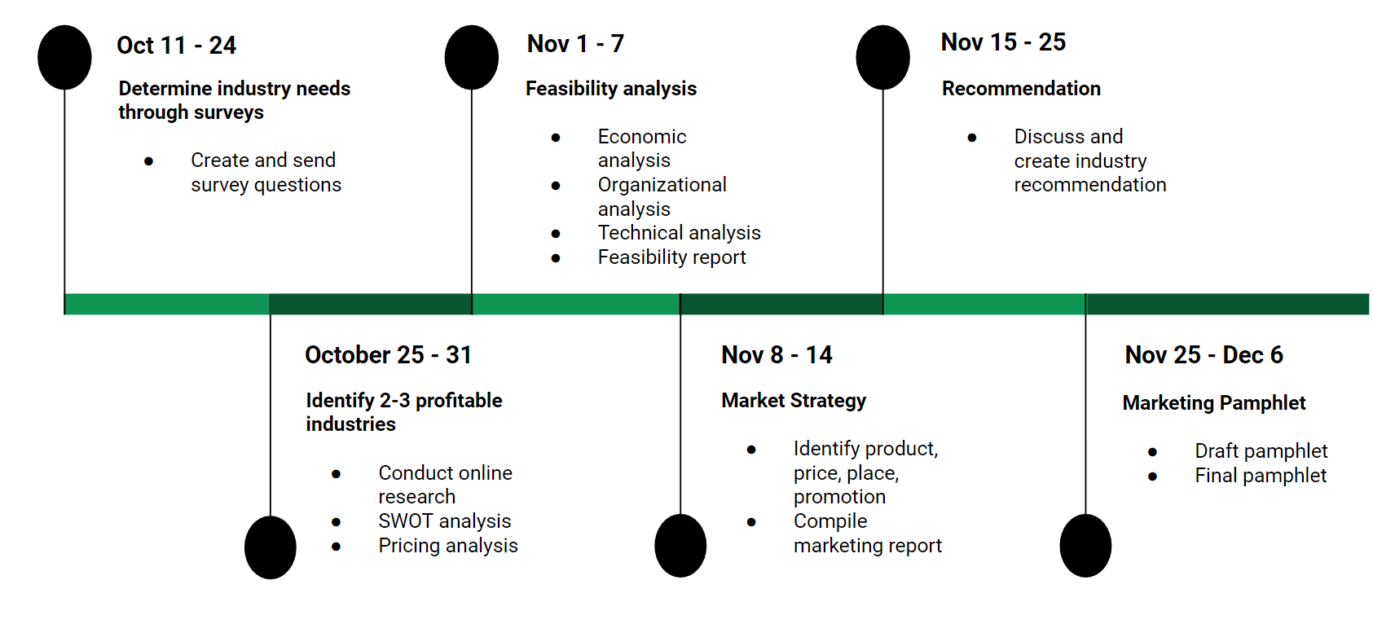

**Figure 1.** Timeline of the project

To understand the different level of tasks -- whether it’s the entire Project, Deliverables, Work Packages, and Tasks -- A Work Breakdown Structure was created.

MAYBE TIME GOES LAST (Link to appendix Gantt Chart)

## Work Breakdown Structure

The work breakdown structure (WBS) provides a visual representation of all the necessary tasks required to complete the project. The WBS is the first thing that was completed in preparation for this project, as it is important to lay the groundwork for our tasks so a project is not overwhelmed. The WBS is presented in a vertical tree structure, reading from top to bottom, and indicates four different levels that lead up to the completed project from one to four. A code is assigned to indicate the level of each component in the WBS in ascending order: with one digit as level one being the objective (1), two digits (1.1) indicating a deliverable, three digits (1.1.1) indicating a work package, and four digits (1.1.1.1) indicating a task and being level four.

As seen in Figure 2, there are three main *deliverables* for Bridgemark Management: Market Research, Market Plan, and Market Proposal. Underneath those, there are six total work packages to complete each deliverable, as well all the tasks to complete each work package.

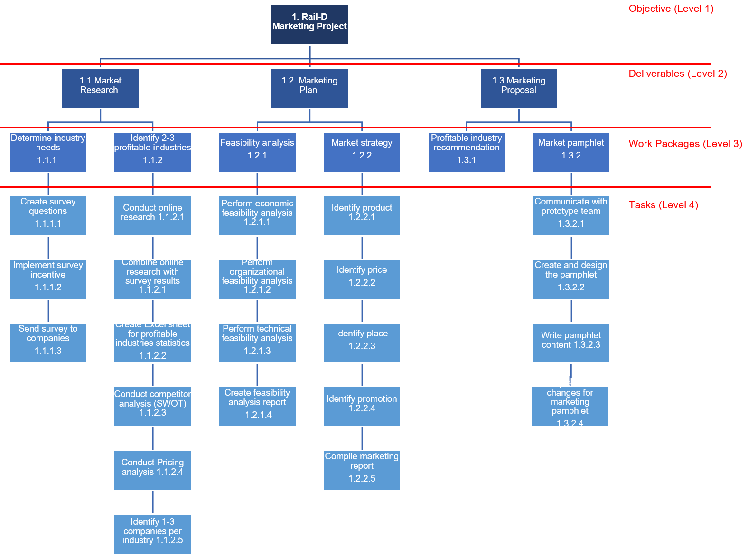

**Figure 2**. Work breakdown Structure

The details of each component of the WBS will be further illustrated in the Work Breakdown Dictionary which show the details of each task.

## Work Breakdown Dictionary

The Work Breakdown Dictionary, shown in table 5, was created from the Work Breakdown Structure (Figure 2) and includes the Work Packages (level 3), and Tasks (level 4); but also details the task owner, dependencies, hours worked, and when each task is expected to conclude. We decided to use a “Project Style” WBS, where task owners can complete tasks in their own time. The hours per task were allocated to determine a realistic finish date (See Appendix A on page 16 for the detailed Work Breakdown Dictionary).

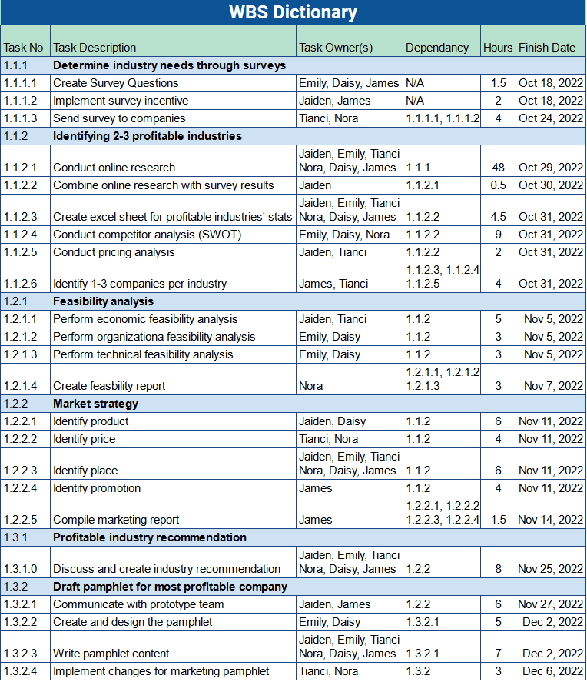**Table 5.** Work Breakdown Dictionary

## Schedule

## The schedule indicates what order we will complete each task. For brevity, we cut down the tasks to only include “key tasks” in this section, which are those we determined to have the most impact. The schedule is calculated in two parts:

* **The Network Diagram:** Displays the key tasks in a map which shows the preceding and subsequent tasks of each key task. It also bundles the tasks into phases, and distributes each task to a letter.
* **Critical Path Method:** Indicates the most efficient path to complete the tasks with the least time possible, done by calculating Late Start – Early Start (or Late Finish – Early Finish):
  + Early start: earliest time a task can begin
  + Early finish: earliest time a task can finish
  + Late start: latest time an activity can start
  + Late finish: latest time an activity can finish

## Network Diagram (Critical Path, Slack, Total Duration)

The WBS (Figure 2) shows six important work packages. From that, we made a Network Diagram (Figure 3) of the subsequent levels contained in each work package. The Network Diagram includes a letter indicating each task and its duration, and is divided into four main phases:

* **Phase 1:** Surveys (2 weeks)
  + Create survey questions and send them to potential target companies.
* **Phase 2:** Online research (1 week)
  + Conduct online research and summarize findings.
* **Phase 3:** Feasibility and market analysis (2 weeks)
  + Conduct feasibility and market analysis of the identified target companies.
* **Phase 4:** Pamphlet (3 weeks)
  + Draft a digital B2B pamphlet from our research for Bridgemark’s marketing 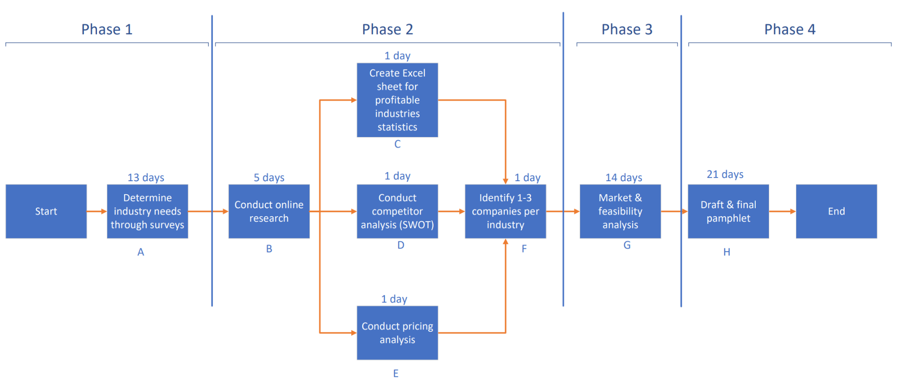

**Figure 3.** Network Diagram with Critical Path

**Critical Path Method (CPM)**

The Critical Path Method (CPM) in Figure 4 illustrates the critical and non-critical tasks that affect the scheduling of the project. *Critical tasks* are tasks which determine the project’s success and follow the critical path. These include:

* Determine industry needs through surveys
* Conduct online research
* Conduct analysis (SWOT)
* Identify 1-3 companies per industry
* Feasibility and market analysis
* Draft and final pamphlet

There is 0 “slack”, indicating that all tasks are crucial to the success of the project. Each task needs to be completed on time to meet the project deadline. There are no non-critical tasks, which is a task that is not a crucial part of the project.

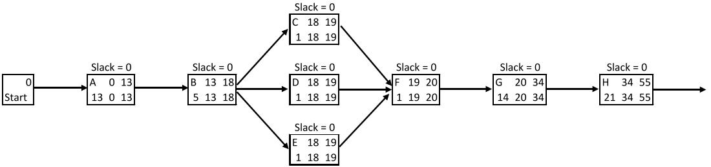



**Figure 4.** Critical Path Method (CPM)

## 2.5 Gantt Chart

The Gantt Chart (figure 5) illustrates our project progress visually. The timeline displays the overall schedule (including weekends) of all six items of our work package. It indicates when work is expected to complete, which work package precedes the other, and the assigned start/end dates for said tasks over the duration of the project. 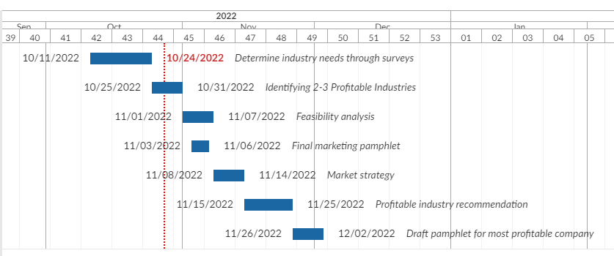

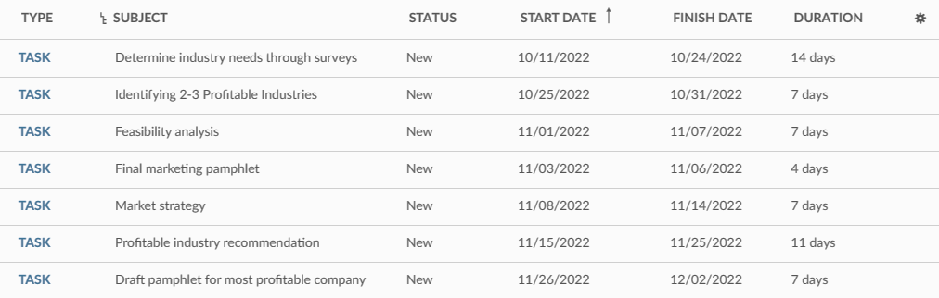

**Figure 5.** GANTT Chart

## 2.6 Communication Strategies

Clear and concise communication eliminates confusion and misinterpretations. There are designated platforms for communicating with various stakeholders. Below are our communication strategies with various stakeholders:

* **External stakeholders:** via email for documentation purposes and acts as a formal method of communication to ensure participation and engagement of targeted audiences
* **Internal stakeholders:** via Zoom to facilitate discussions and provide status updates. Zoom meetings ensure that members will actively participate in discussions and communicate relevant information that pertains to the progress of the project.

Refer to Appendix C for a detailed breakdown of our communication plan.

## 2.7 RACI Matrix

The RACI matrix (Table 6) designates at least one team member for every element of RACI (Responsible, Accountable, Consulted, Informed) to every key task. AbovetheCurve members to be aware of others’ tasks in addition to their own. We also ensured each member was only responsible for 2-3 subtasks, in order to avoid over/under allocation of work.

Documentation providing clear, reallocated responsibilities allows easier identification of potential delays or accidental overlap of assignments (i.e. two members each working on one assignment separately, thinking it was their own).

| **RACI Matrix** | | | | | | | | |
| --- | --- | --- | --- | --- | --- | --- | --- | --- |
| **Name** | **Simran** | **Emily Chan** | **Daisy Huynh** | **James Lee** | **Jaiden Angeles** | **Tianci Qiao** | **Nora Dai** | **Prototype Group** |
| **Determine industry needs through surveys** | | | | | | | | |
| Create Survey Questions |  | R | R | R | I | A | I |  |
| Implement survey incentive | I | I | A | R | R | I | I |  |
| Send survey to companies | C | I | I | C | A | R | R |  |
| **Identifying 2-3 profitable industries** | | | | | | | | |
| Conduct online research |  | R | R | R | R & A | R | R |  |
| Combine online research with survey results |  | I | I | A | R | I | I |  |
| Create excel sheet for profitable industries' statistics |  | R | R | R | R | R & A | R |  |
| Conduct competitor analysis (SWOT) |  | R | R | I | A | I | R |  |
| Conduct pricing analysis |  | I | I | I | R | R | A |  |
| Identify 1-3 companies per industry |  | I | A | R | C | R | I |  |
| **Feasibility analysis** | | | | | | | | |
| Perform economic feasibility analysis |  | A | I | I | R | R | I |  |
| Perform organizational feasibility analysis |  | R | R | I | I | A | I |  |
| Perform technical feasibility analysis |  | R | R | I | I | I | A |  |
| Create feasibility report |  | I | I | A | C | I | R |  |
| **Market strategy** | | | | | | | | |
| Identify product | C | A | R | I | R | I | I | I |
| Identify price | C | I | I | A | I | R | R | I |
| Identify place | C | R | R | R & A | R | R | R | I |
| Identify promotion | C | I | I | R | I | I | A | I |
| Compile marketing report | C | A | I | R | C | I | I | I |
| **Profitable industry recommendation** | | | | | | | | |
| Discuss and create industry recommendation | C | R | R & A | R | R | R | R |  |
| **Draft pamphlet for most profitable company** | | | | | | | | |
| Communicate with prototype team | I | I | A | R | R | I | I | R |
| Create and design the pamphlet |  | R | R | I | I | A | I |  |
| Write pamphlet content |  | R & A | R | R | R | R | R |  |
| **Final marketing pamphlet** | | | | | | | | |
| Implement changes for marketing pamphlet | I | I | I | I | A | R | R |  |

**Table 6**. Simplified RACI Matrix

# Budget, Risks and Change Management

## 3.1 Risk Register/Contingency Plan

Table 7 is a risk register that shows a list of risks, impacts, responses, and risk levels. The risk register indicates the various risks associated with the project plan and will assist the team in creating a comprehensive project plan that can effectively mitigate potential risks.

The looming fears of a recession will almost certainly affect our primary data set (surveys) and therefore our analysis & findings as well.

| ID | Risk | Impact | Response | Risk Level |
| --- | --- | --- | --- | --- |
| 1 | Survey Grant money incentive rejected | Unanswered surveys | Find alternative funding | Very low |
| 2 | Online sabotage of surveys | Data discrepancies | Manually review survey results | Very low |
| 3 | Insufficient data from survey responses | Inadequate data | Send surveys to more industries | Low |
| 4 | Inadequate information sources  (Since new product research is sparse) | Inferior research | Find similar products for benchmarks | Medium |
| 5 | Unexpected competition  or new product | Lower RAIL-D demand | Expedite the research process for faster release | Very low |
| 6 | Server shutdown  (i.e. Google, Bookstack) | Miss targeted deadlines | Backup files | Very low |
| 7 | General Economic Downturn | Downward pressure on market confidence | N/A | Very high |
| 8 | Supply chain issues for Bridgemark’s RAIL-D | RAIL-D becomes costly | Pre-locate alternative parts | Low |
| 9 | Termination of Sponsor | End or delay of project | Consistent contact with Bridgemark | Very low |
| 10 | Disapproval of stakeholders | Delay of project | Learn/adapt stakeholder’s expectations | Very low |
| 11 | Regulatory/ legislative roadblocks | RAIL-D becomes costly or unfeasible | Research regulations in Canada on data collection | Very low |

**Table 7.** Risk Register and Contingency Plan

## 3.2 Evaluation Strategies

Below are some evaluation strategies for the proposed project plan:

1. **Correlation analysis**. As with any sample, the veracity of our data set as a representation of the population is *positively* correlated with N (number of responses). Since we predict that many participants will not complete the survey in full (resulting in differing N values for individual questions), the confidence intervals will consequently be different as well. Some methods of analysis will only be statistically significant if we receive enough inputs, and thus our eventual recommendations will take these variations into account.
2. **Relevance**. The proposed project plan should align with the sponsor's objectives. Upon completion of the project, the recommendations should provide a feasible solution and receive positive feedback from the project sponsor.
3. **Key Performance Indicators (KPI)**. Regarding surveys, we can measure the response rate of our surveys. If we get over 60% responses indicating that firms are interested in real-time data collection, this indicates that there are many companies in the market that are interested in utilizing the AI data collection tool that Bridgemark offers.
4. **Feasibility analysis.** The feasibility analysis will be done based off the economic, technical, and organizational viability of the proposed plan:

* **Economic:** The short-term nature of our project necessitates minimizing additional costs, as this would eat directly into Bridgemark’s gross margin. As Bridgemark will be introducing a new tool to the market during what is predicted to be a severe economic downturn (see appendix E), our emphasis will be on ensuring that there is sufficient market demand for the project to have a positive return for Bridgemark.
* **Technical:** The technical feasibility will be primarily in the domain of the prototype team. Above the Curve will be focusing more on potential and likely requirements of end-users, communicating that information with the prototype team, and how to best tailor the technical specifications of RAIL-D for maximum market appeal.
* **Organizational:** The ease of implementation is a top priority for organizations. Part of our marketing proposal will be centered around the reliability of the tool as part of their business processes, which replaces human error potential with margins of error and allows for streamlined integration with management analytics.

## 3.3 Project Budget

Based on the WBS Dictionary, we are using bottom-up budgeting to determine the list of necessary resource budgets required for each of the major work activities. Some direct and indirect costs to the project activities include labour, gas, website subscription, and transit costs. Building a project budget helps to support the project and goals by providing an estimate of the costs for each activity. *Table 8* below shows a breakdown of the budget.

| WBS | Task | Variable (Labour & gas) | Fixed  (Subscription & transit) | Budget |
| --- | --- | --- | --- | --- |
| 1.1.1 | Determine industry needs through surveys | $124.57 | $106.58 | $231.15 |
| 1.1.2 | Identifying 2-3 profitable industries | $1,062.02 | $53.29 | $1,115.31 |
| 1.2.1 | Feasibility analysis | $221.78 | $53.29 | $275.07 |
| 1.2.2 | Market Strategy | $338.48 | $53.29 | $391.77 |
| 1.3.1 | Profitable industry recommendation | $147.91 | $106.58 | $254.49 |
| 1.3.2 | Draft pamphlet for most profitable company | $268.46 | $53.29 | $321.75 |
| 1.3.3 | Final marketing pamphlet | $50.62 | $53.29 | $103.91 |
| Total budget |  |  |  | $2,693.45 |

**Table 8.** Budget Breakdown

**Fixed:** The fixed cost includes website subscription and transit cost, and are allocated to each project activity based on the number of days needed to complete each task. For the website subscription, we have used the average cost of $6 per day in 2022. For transit costs, we have used the fixed cost of $176.80 each student needs to pay every semester.

**Variable:** The variable cost consists of labour and gas. The total variable cost is allocated to each project activity based on the number of days needed to complete each task. For labour, we are using BC’s minimum wage of $15.56 per hour. For gas, we are taking the distance from home to campus multiplied by the average gas price of $2.43/L in Vancouver, between July and October, to calculate the total cost for gas.

**Budget:** The budget is the fixed cost + variable cost. It shows the amount of the funding required for each task.

## 3.4 Conclusion

Bridgemark Advisory Services’ upcoming RAIL-D (Remote Artificial Intelligence Logo

Device) project has exceptional potential; the set of data otherwise unobtainable is intrinsically valuable for data analytics. Above the Curve Consulting will be providing a

feasibility analysis to help ensure that the introduction of RAIL-D in current market conditions is successful.

In order to identify the potential companies, our team will perform a market analysis on a few

selective industries. The feasibility analysis will inform us of the economic, organizational,

and technical feasibility of acquiring customers in the targeted industries. The market

analysis will provide the basis on which we grade the relative attractiveness of select firms,

and based on our findings, we will be suggesting 2-3 potential clients/partners that can utilize

Bridgemark’s ground-breaking device in the short term.

Out of all the risks involved in Bridgemark’s project, arguably the most impactful area of

concern is the record low levels of consumer & business confidence (sources in appendix E).

Rampant inflation, a global energy shock, geopolitical tension between the U.S. and China,

and the ongoing Russia-Ukraine War will most likely lead to a global recession in the near

future.

Furthermore, since this is an ongoing trend with no foreseeable resolution in the short-term,

expert opinions vary wildly on the impact of this recession. Despite this, Above the Curve is

confident that, given the right marketing & pricing strategy, Bridgemark’s RAIL-D can find

its rightful place in the market.

# Appendices

**Appendix A: Work Breakdown Structure**

A detailed version of the work breakdown structure, listing out all key tasks.

*Figure A1. Detailed Work Breakdown Structure*

**Appendix B:** AdvancedWork Breakdown Dictionary

A detailed version of the Work Breakdown Dictionary, listing out: Task No, Task Description, Task Owners, Dependencies, Hours, Costs, Start Date, Estimated Days, and Finish Date.

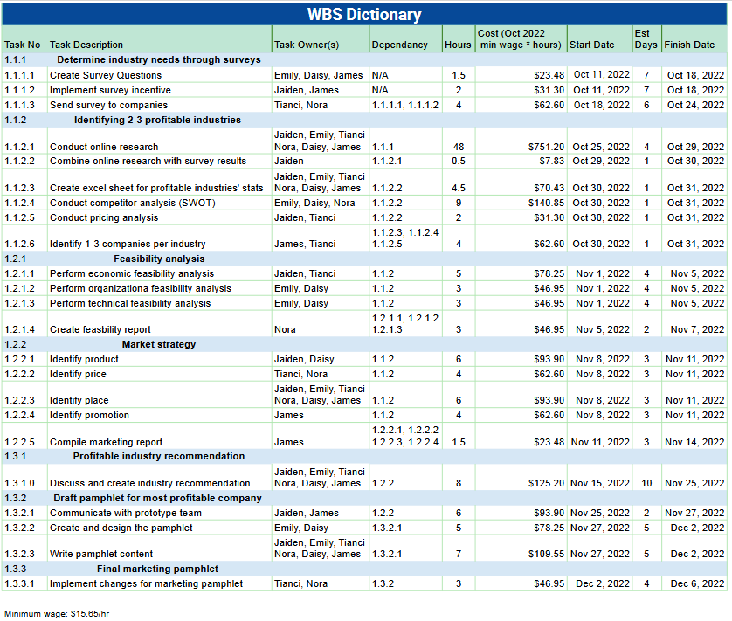

*Figure B1. Detailed Work Breakdown Structure*

**Appendix D: Communication Plan**

A communication plan provides substantial information that needs to be communicated to specific stakeholders through certain channels.

*Table D1. Communication Plan*

| **Milestones** | **Purpose** | **Team Contact** | **Stakeholders** | **Due Date** |
| --- | --- | --- | --- | --- |
| Determine scope of project | Identify business problem and provide recommendations | Sponsor, Team members | Sponsor, team members | Oct 1 |
| Collect survey response | Provide information on target industry | Team members | Team members | Oct 24 |
| Finish conducting online research | Provide data on target industries | Team members | Team members | Oct 31 |
| Analyze market research data | Interpret data and provide information on target industries | Team members | Team members | Oct 31 |
| Identifying 2-3 industries | Narrow down focus companies | Sponsor, Team members | Sponsor, Team members | Oct 31 |
| Feasibility analysis | Ensure economic viability of project | Sponsor, Team members | Sponsor, Team members | Nov 7 |
| Marketing strategy analysis | Demonstrate value proposition for project | Sponsor, Team members | Sponsor, Team members | Nov 14 |
| Pamphlet | Illustrate market research and plan of project | Sponsor | Sponsor | Dec 6 |
| Presentation | Deliver relevant information regarding short-term marketing plan | Sponsor, prototype team, long-term marketing team | Sponsor, prototype team, long-term marketing team | Dec 6 |

| **Continuous Meetings** | **Purpose** | **Stakeholders** | **Stakeholders** | **Frequency** |
| --- | --- | --- | --- | --- |
| Kickoff meeting | Review goals and roles | Team members | Team members | Once |
| Status report | Give status update | Sponsor, team members | Sponsor, team members | Weekly |
| Meet prototype team | Relay and obtain information on software of tool | Prototype team members | Prototype team members | As needed |
| Team meeting minutes | Make task list and give tasks among team | Team members | Team members | Weekly |
| Scope change reporting | Update objectives for client's needs | Sponsor, team members | Sponsor, team members | As needed |
| Presentation rehearsal | Practice presentation | Team members | Team members | As needed |

**Appendix E: Sources for market downturn prediction**

[Conference Board of Canada. (2022 October). *Index of Consumer Confidence: September & October.* Conference Board of Canada. https://www.conferenceboard.ca/e-library/abstract.aspx?did=11822 https://www.conferenceboard.ca/e-library/abstract.aspx?did=11863](https://www.conferenceboard.ca/e-library/abstract.aspx?did=11822)

OECD (2022), Business confidence index (BCI) (indicator). doi: 10.1787/3092dc4f-en https://data.oecd.org/leadind/business-confidence-index-bci.htm#indicator-chart